EXPT NO:6 | INTEGRATE DATA FROM VARIOUS SOURCES FOR COMPREHENSIVE ANALYSIS USING TABLEAU AND POWERBI
DATE: 24.07.2026

PRE-LAB QUESTIONS (PROVIDE BRIEF ANSWERS TO THE FOLLOWING QUESTIONS)

- What is data integration in the context of Business Intelligence (BI)?

Data integration is the process of combining data from different sources such as Excel, CSV files, databases, and online sources into a single system. In BI, it helps create a unified view of data so that users can analyze it and make better decisions.

- Explain the difference between a join and a data blend in Tableau.

A join combines tables using a common field and is usually performed at the data source level before analysis. A data blend combines data from different data sources using a common field while creating a visualization. Joins are generally used when data is in the same data source, while blending is useful when data comes from separate sources.

- What are relationships and cardinality (e.g., one-to-many, many-to-many) in Power BI's data model?

A relationship defines how two tables are connected using a common column. Cardinality describes how records in one table relate to records in another table. For example, in a one-to-many relationship, one record in one table can be related to many records in another table. In a many-to-many relationship, multiple records in both tables can be related to each other.

- Why is data quality (e.g., consistent naming conventions, data types) crucial when integrating data from different sources?

Good data quality is important because inconsistent names, incorrect data types, missing values, and duplicate records can lead to incorrect analysis and misleading results. Maintaining consistent data ensures that different sources can be combined correctly and produces accurate BI reports and dashboards.

- Name two common challenges encountered during data integration.

Two common challenges are:
- Inconsistent data formats and data types between different sources.
- Missing, duplicate, or incorrect data that needs to be cleaned before integration.

IN-LAB EXERCISE:
OBJECTIVE:
To connect to, combine, and model data from multiple disparate sources in Tableau and Power BI to create a unified, comprehensive dashboard for holistic analysis.

PROCEDURE:
- Data Collection:
  - Import data from at least two different sources (e.g., a CSV file and an Excel file).
  - Dataset 1: Sales Data (CSV file) with fields like Order ID, Order Date, Region, Sales Amount.
  - Dataset 2: Regional Sales Targets (Excel file) with fields like Region, Sales Target, Target Year.
- Data Preparation and Transformation:
  - Clean both datasets: Check for inconsistencies in region names (e.g., "N. America" vs. "North America").
  - Ensure data types are correct (e.g., Sales Amount is numeric, Order Date is a date).
  - Handle any missing values as appropriate.
- Data Integration and Modeling:
  - Tableau: Use the Data Source pane to establish a relationship or join between the Sales Data and Regional Targets tables using the common Region field.
  - Power BI: Use the Model view to create a relationship between the two tables, connecting them on the Region column. Define the cardinality (e.g., many-to-one).
- Create Calculated Fields for Comparison:
  - Develop new measures that leverage both datasets.

  - Examples: Target Achievement % = (SUM(Sales) / SUM(Sales Target)) * 100
  - Sales vs. Target Variance = SUM(Sales) - SUM(Sales Target)
- Design a Comprehensive Dashboard:
  - Create visuals that combine data from both sources to provide a single view of performance.
  - Add KPI cards for Total Sales and Overall Target Achievement %.
  - Use a gauge chart or bullet chart to show sales performance against targets for each region.
  - Create a combined bar chart showing Actual Sales vs. Target Sales by Region.
  - Use a map to visualize the Sales vs. Target Variance, highlighting underperforming or overperforming regions.
- Validate Data Integrity:
  - Verify that the joined/related data is accurate by cross-checking values.
  - Ensure filters on the dashboard correctly update visuals that use data from both sources.
- Publishing and Sharing:
  - Tableau: Publish the workbook to Tableau Public or Tableau Server.
  - Power BI: Publish the report to Power BI Service and share the link. Experiment Datasets:
Dataset 1: Retail Sales Data (CSV) Fields Used:
- Order ID – Unique identifier for each order
- Order Date – Date of the sales transaction
- Region – Sales region
- Sales – Sales revenue from the order
Dataset 2: Regional Sales Targets (Excel) Fields Used:
- Region – Sales region (used as the key for joining/relationship)
- Sales Target – The sales goal for the region
- Target Year – The year for which the target is set

Power BI:

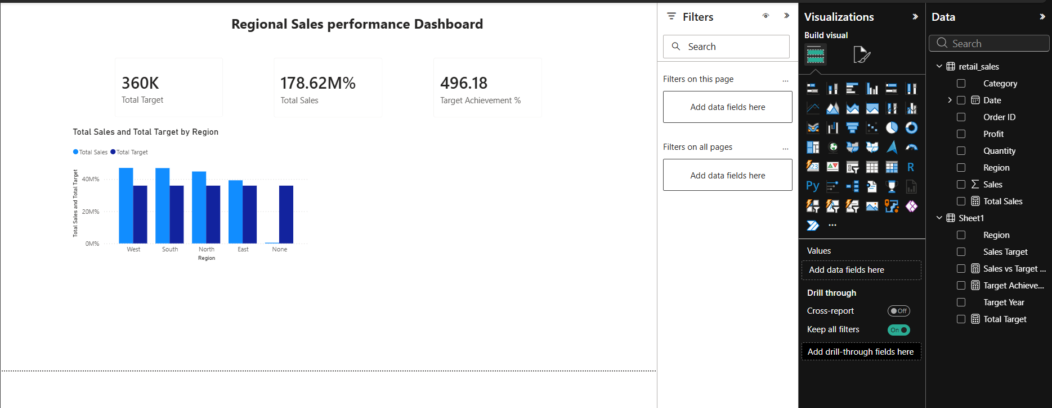

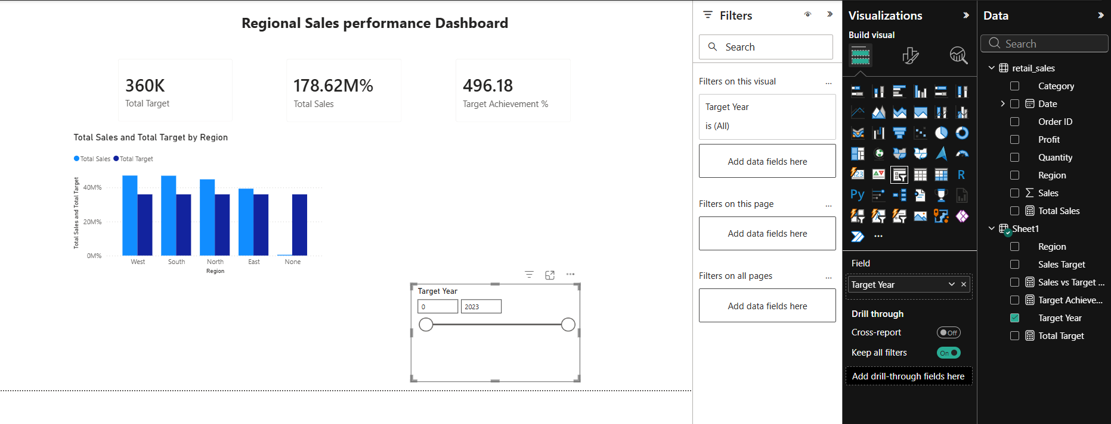

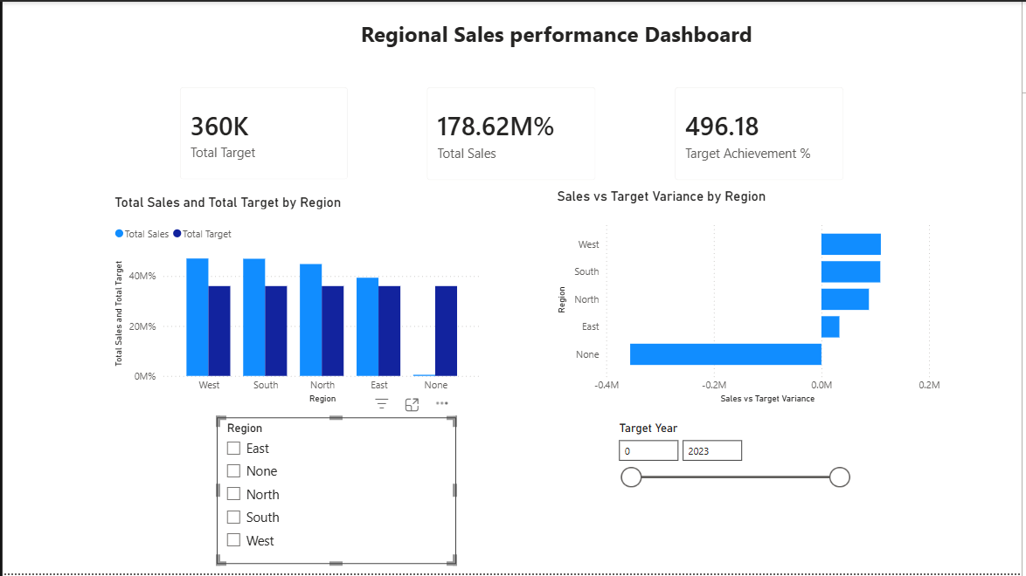

Tableau:

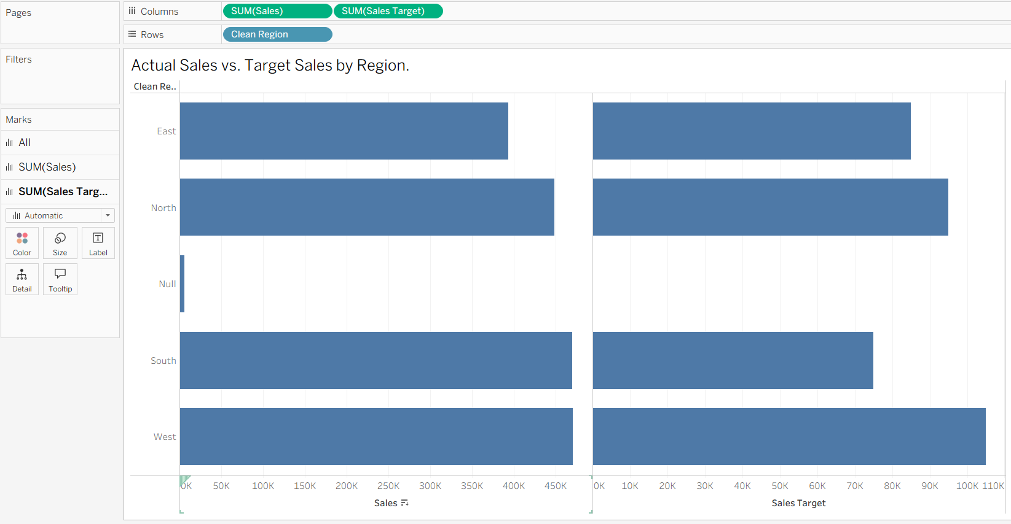

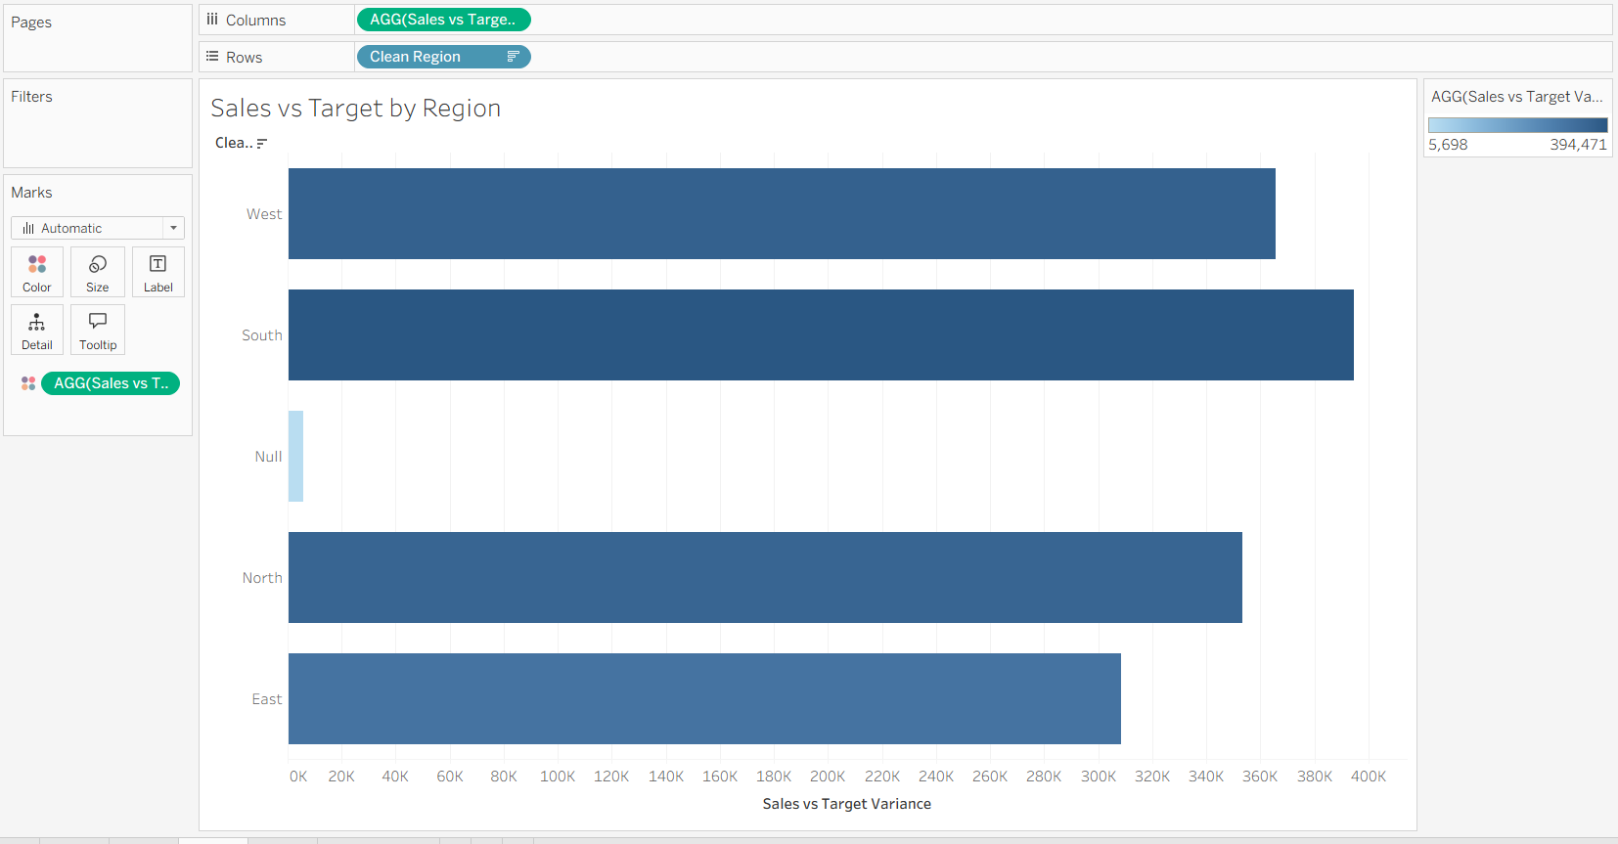

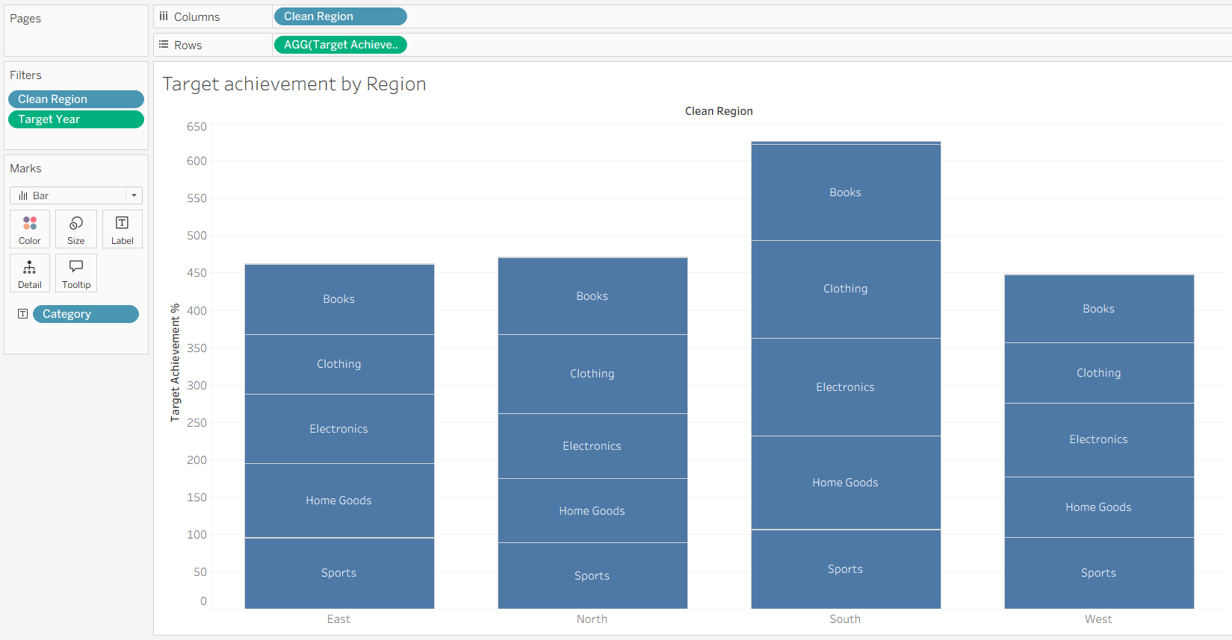

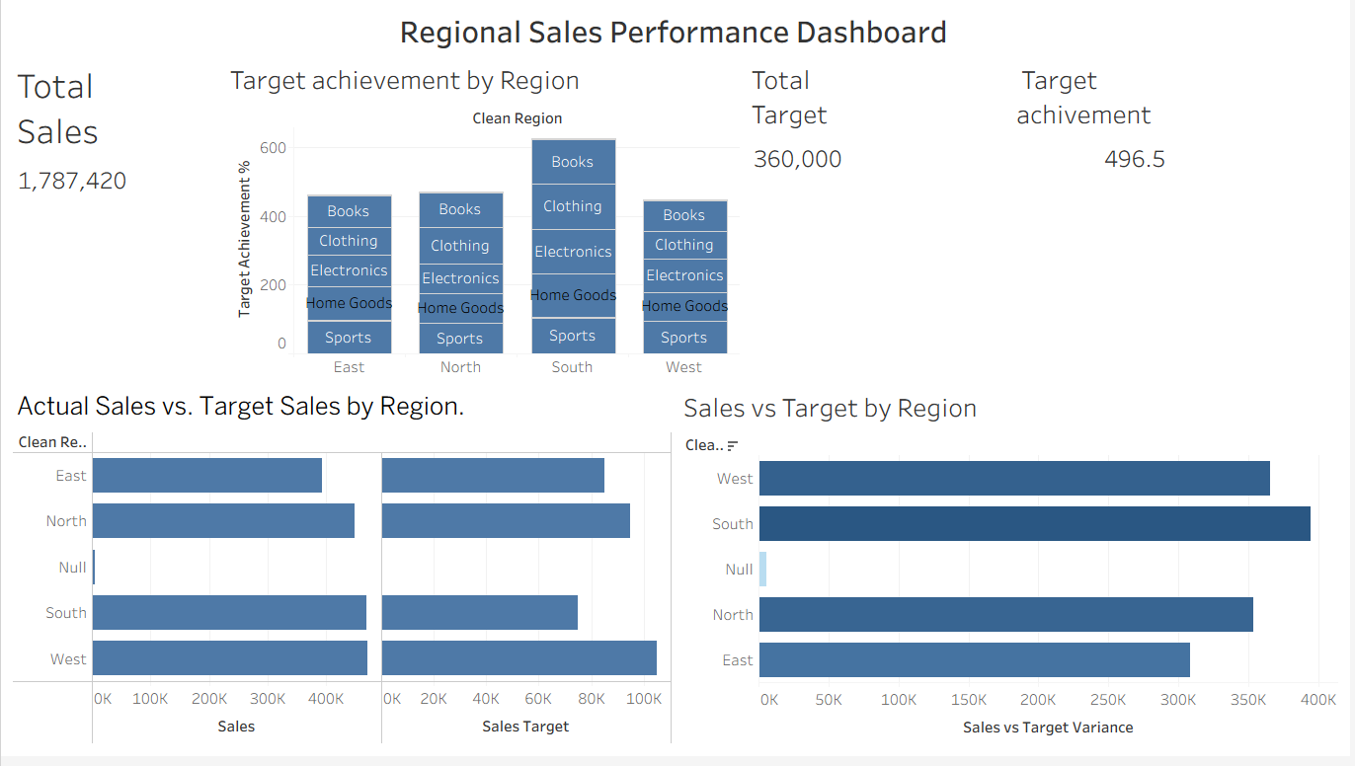

POST-LAB QUESTIONS (PROVIDE BRIEF ANSWERS TO THE FOLLOWING QUESTIONS)

- How did integrating the sales targets data provide a more complete analytical picture than using the sales data alone?

Integrating sales target data allowed us to compare actual sales with the planned sales targets for each region. Sales data alone shows how much was sold, but target data helps us understand whether the business met, exceeded, or fell below its goals. This provided a better overall view of regional performance.

- Describe the type of join or relationship you used to combine the two datasets and explain why it was the appropriate choice.

We used a relationship based on the common Region field between the Retail Sales CSV and Regional Sales Targets Excel file. In Power BI, we used a many-to-one relationship, because the sales data contains many orders for each region, while the target data contains one target value for each region. This was appropriate for comparing actual sales with regional targets.

- What challenges, if any, did you face regarding data granularity or mismatched keys (e.g., different region names) between the two sources?

The main challenge was ensuring that the Region names were consistent in both datasets. Missing values such as null, NaN, and nan also had to be handled and combined as Unknown. We also had to ensure that the sales data had multiple order-level records while the target data had one target per region, so the data was correctly related without duplicating target values.

- How can creating variance calculations (e.g., Sales vs. Target) help a business manager make better decisions?

Variance calculations show the difference between actual sales and the target. A positive variance means the region is performing above the target, while a negative variance indicates underperformance. This helps managers identify weak regions, take corrective actions, set better targets, and allocate resources more effectively.

- What other data source (e.g., marketing campaign data, customer demographics) could you integrate to further enrich this analysis, and what new insights might it provide?

We could integrate marketing campaign data containing advertising expenses, campaign dates, and campaign performance. This could help identify whether marketing campaigns increased sales in specific regions. It would also help managers understand the relationship between marketing spending and sales performance and make better decisions about future campaigns

RESULT:
The retail sales and regional targets datasets were successfully connected, cleaned, and integrated in both Tableau and Power BI. By creating relationships between the sources, a unified data model was built. The resulting comprehensive dashboard visualized sales performance against set targets, enabling variance analysis and providing deeper, context-rich insights into regional performance that were not possible with a single data source.

ASSESSMENT

Description | Max Marks | Marks Awarded
Pre Lab Exercise | 5
In Lab Exercise | 10
Post Lab Exercise | 5
Viva | 10
Total | 30
Faculty Signature

